Working With Dataset

# Exploration Of Data

|  |  |
| --- | --- |
| Team ID | PNT2022TMID04459 |
| Project Name | Visualizing and Predicting Heart Diseases with an Interactive Dashboard |

## Dataset Link:

<https://www.kaggle.com/datasets/rishidamarla/heart-disease-prediction>.

## About Dataset:

This is a kaggle dataset. It contains 14 fields. The goal of the dataset is to predict the presence of heart disease.

## Dataset Exploration:

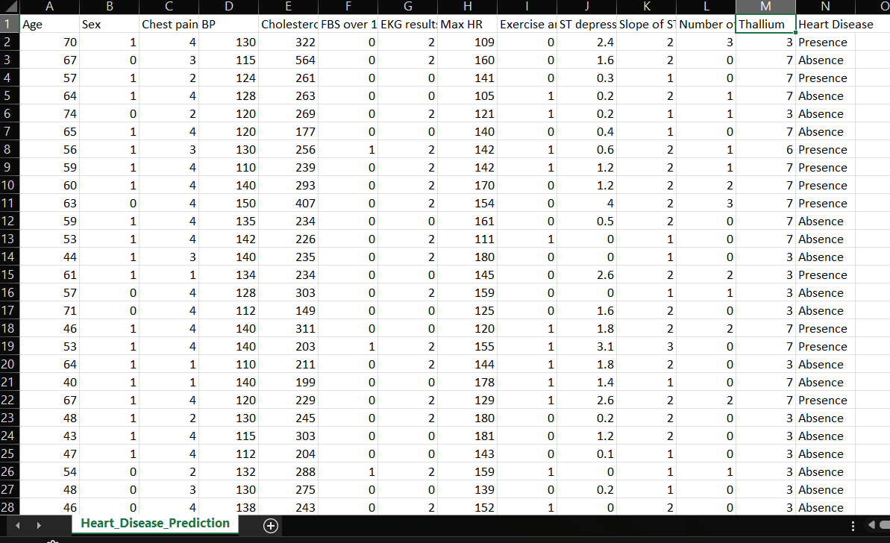

* Dataset contains 270 rows and 14 columns.
* There are no missing values in the dataset.

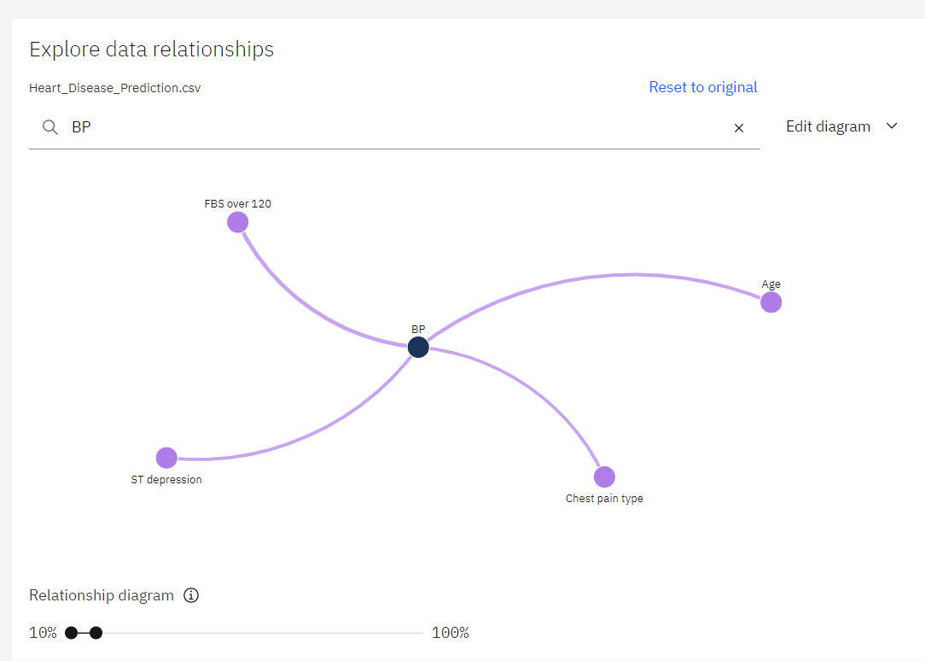

1. BP is related to FBS over 120, ST depression, Chest Pain Type, Age over strength 10 % to 16 %

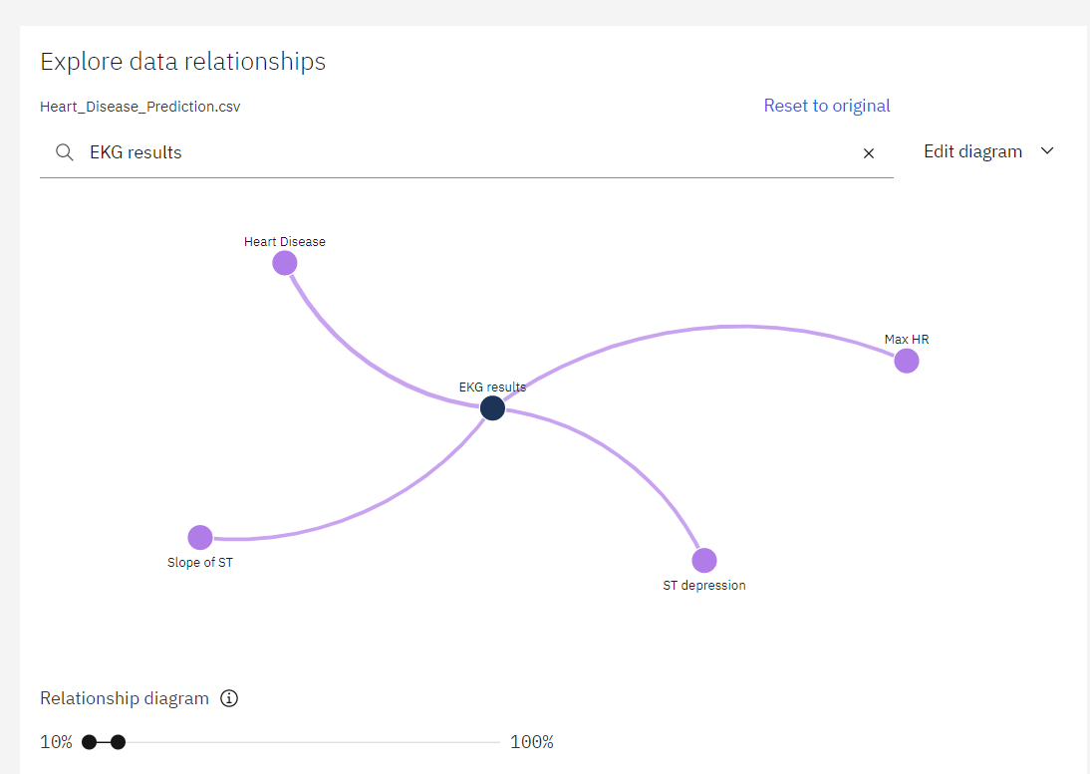

1. EKG results are related to Slope of ST, ST Depression, Max HR and Heart Disease.
2. As the values ST depression, Slope of ST and Max HR are calculated using EKG results, it is clear that the relationship diagram is correct.

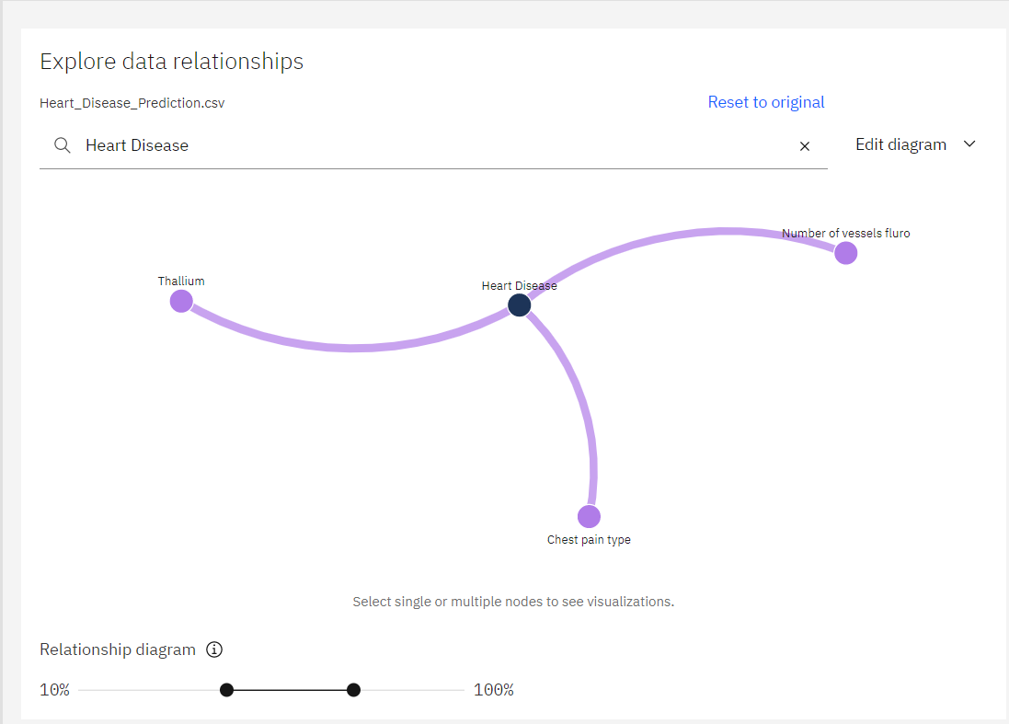

1. For the relationship strength over 45% to 75%, Heart disease is highly related to Thallium, Chest Pain Type and Number of vessels fluro.